CountBOX [Shopify](https://shopify.com/) Connector

• WebHook documentation: <https://help.shopify.com/api/tutorials/webhooks>

• Service location: [terminal.countbox.us/shopify­connector/](https://bitbucket.org/denis_ryabikov/countbox-shopify-connector/src/edac16eea7ba68cb30c0297fcc3fa6f4d1a06e98/terminal.countbox.us/shopify-connector)

• CountBOX support portal: [http://support.countbox.us](http://support.countbox.us/)

Step1: In the Shopify admin page, please locate Settings:

2

ber 5, 2016

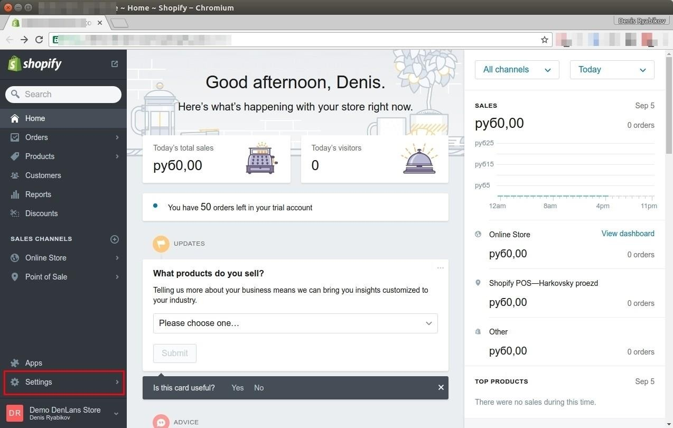

Septem

Step 2: Navigate to Notifications

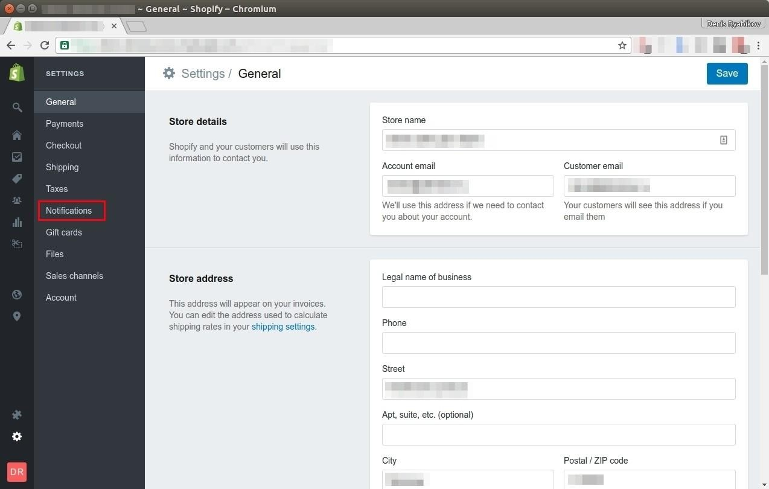

September 5, 2016

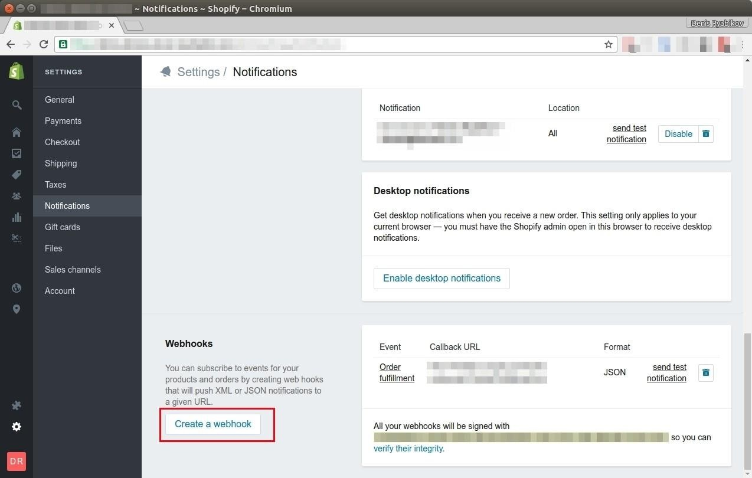

Step 3: Then locate Webhooks. Click on “Create Webhook”

4

Step 4: Please select from available option in the field 1 and 2 and make selections as shown on picture, in the field 3 insert Webhook URL, provided by

CountBOX support

5

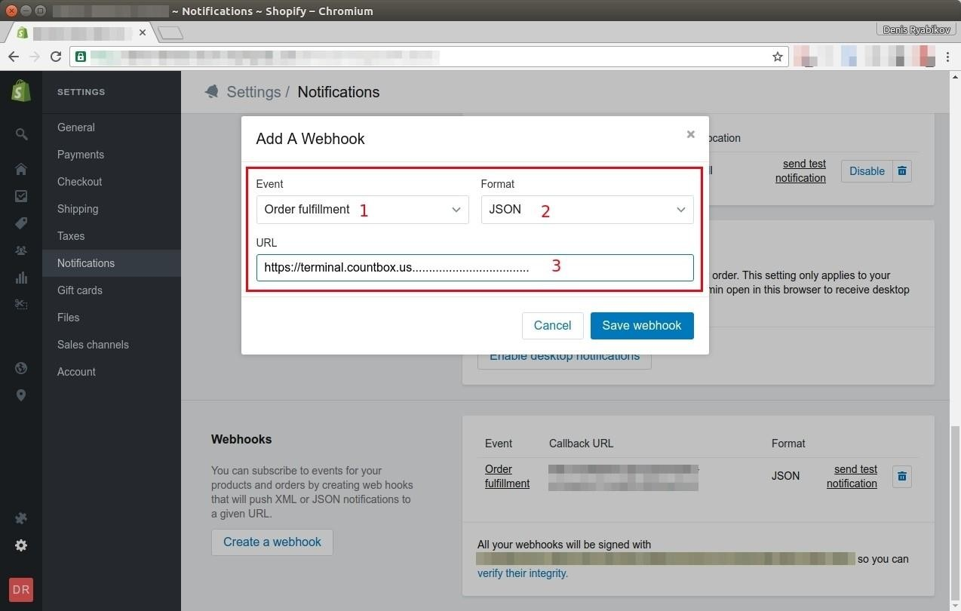

Step 5: Please provide to CountBOX support values from the field ("webhooks will be signed with"). CountBOX support will Validate notification sent and if all good we done. Otherwise may need to recreate webhook (please refer to Step 3 of this manual)

6

